March 24, 2020

Bradley De Ath

DEA18001355

Professional Skills and Industry Practices

SCGT46 | Assignment 1

Contents

Section 1 1

Software Development Frameworks 1

Scrum Framework 1

Extreme Programming 1

Project Management Tools 2

Gitlab 2

Microsoft Azure 3

Section 2 3

A Mobile App for a Local Hairdresser 4

The Role of Project Management 4

The Scale of Business Analysis 4

Development Methodology 5

A Large-Scale Online Shopping Platform for a National Retailer 5

The Role of Project Management 5

The Scale of Business Analysis 6

Development Methodology 6

Appendix 7

Bibliography 8

# Section 1

## Software Development Frameworks

### Scrum Framework

A Scrum, one of the most used agile software development frameworks, is useful for ensuring appropriate team management when developing software. The purpose of the scrum when in development, is to ensure that the different developers and teams are all aware of each other’s progress and intentions. Within the Scrum framework, tasks and requirements are micro-managed, through short frequent meetings between those involved in the “sprint” (The period focussed on achieving the specific tasks). These meetings are used to properly ensure that the tasks are achievable in time and to a high enough standard **(Scrum, 2018)**.

Through the frequent options to adapt the plan of action for the development, better team management is possible for all of those involved. With the ability for team members to report on their progress daily **(Scrum.org, n.d.)**, suitable changes to aspects such as team composition and resource management can be implemented quicker, allowing for better workflow from the teams. In other frameworks where progress meetings are held less frequently, team members may end up working in setups that aren’t best for them for longer periods, reducing efficiency and output.

On top of team management, the Scrum framework is useful for supporting teamwork and ensuring that those working on the software can work efficiently together. As can be seen in the following case study, **(Moe, Dingsøyr and Dybå, 2010)**, adopting the Scrum framework can be a possible improvement to the teamwork of the teams, but is not without its difficulties. Through implementing the Scrum framework, underlying issues in teams’ composition and orientation can be identified and improved.

However, due to the design of the framework being heavily reliant on frequent communication and socialising, there are times where its use may not be appropriate. With all team members needing to share ideas and return updates to the rest of the team as frequently as every day, situations where these meetings are not feasible or would be difficult to maintain make using Scrum more difficult. In large software development teams with many different members, having them come together every single day to share progress would be more challenging and would take longer than what is ideal for the Scrum framework **(Năftănăilă, 2008)**.

### Extreme Programming

Extreme Programming is another commonly used agile development framework, with the focus being on customer satisfaction. Through a design that leans heavily on frequent feedback with the customer at the forefront of decisions, software and progress is provided as it is needed, avoiding long durations between updates to the client **(Extreme Programming: A Gentle Introduction., n.d.)**. This framework focuses on what has been laid out by the client and //finish

The benefit to teamwork from using this development framework can be seen in a case study on testing the efficiency of XP (Extreme Programming) on a team of programmers **(Johnson and Caristi, 2002)**, with results showing the impact of pair programming during software development: these results showed that using the pair programming technique during development can lead to better harmony between developers as well as better code quality overall. Pair programming is where the programming is done by two programmers (usually on the same workstation), with one developing the content such as source code/diagrams and the other monitoring said content to assure quality and consistency **(Mcdowell, 2003)**.

However, using pair programming does not always guarantee that better harmony will be achieved between developers. Since nature and personalities can vary between different team members on a project, there runs the risk of those working together clashing and not providing benefit to each other. If pairs of developers aren’t consistent and those who are working together changes frequently, it may be hard for team members to feel comfortable due to their methods constantly having to adapt based on who they are working with. If developers are repeatedly working with teammates who they are not used to working with, there can be difficulties in teamwork, and so can result in mistakes or errors in their work **(Arisholm, Gallis, Dyba and Sjoberg, 2007)**. This drawback is more likely to occur in larger teams, due to the wider variation of developers

## Project Management Tools

### Gitlab

Software management tools can also be useful for supporting team management, a key example of this is the code repository service Gitlab. Gitlab is a repository manager that allows for multiple users to view and edit the code stored within the cloud-based repositories **(Gitlab.com, n.d.)**. The use of these repositories helps with team management due to the ability for all team members to individually contribute to the programming without interfering with each other’s progress. Through version control for the repositories, team members can add their own additions to the code without potentially affecting the versions that other team members are currently working on **(Hethey, 2013)**. This is a benefit to team management as each repository can be viewed and assessed by those leading the team to track the work of each individual team member.

On top of the source code repositories within Gitlab, there are tools available to users that can help strength teamwork. One of these tools is the built-in “wiki” that is available for Gitlab projects,which allows for documentation to be stored and viewed alongside the code for the projects **(Wiki | Gitlab, n.d.)**. These wikis are where important documentation can be viewed and edited by the different team members involved, allowing for easy access to up-to-date information for all people involved in the project **(Dittmer, 2019)**. This is useful for supporting teamwork due to the ease of access for up to date information. With the ability to host documents alongside the source code, all team members can easily communicate changes and view important data, making it smoother for them to work cohesively without accidently relying on content that is no longer valid.

## Microsoft Azure

Team Management can also be improved using other project management tools, with another commonly used one being Azure DevOps. Microsoft’s Azure is a cloud-based storage and repository system that multiple team members can manage simultaneously **(What is DevOps? DevOps explained | Microsoft Azure, n.d.)**. Deriving from a mix of “Development” and “Operations”, DevOps is a method of team composition that is designed to reduce the time taken to achieve goals, without sacrificing quality to do so. This is heavily linked into the application lifestyle for software development, as through implementing DevOps, development teams are allowed more freedom and flexibility when completing each of the stages in the lifecycle **(Zhu, Bass and Champlin-Scharff, 2016)**.

This development method is heavily involved in the Microsoft Azure software through the version control that is available. Within Azure, users can store several versions of the same software and information within repositories. Content such as source code and documentation can be withdrawn from the cloud-based Azure storage for use by induvial team members, once the users have completed their desired tasks with the content, the newer version can simply be re-uploaded into the repository for easy use by other team members **(Rossberg, 2019)**. As can be seen in a case study on Team Management in the workplace, **(Melo, Cruzes, Kon and Conradi, 2013)**, results showed that one of the key factors in team co-ordination was the proper allocation of work. Through the simple methods of uploading, retrieving and sharing content for team members using the Azure software: this allocation is made easier, and so can strengthen the efficiency in software development.

However, due the nature of the Azure system there are still drawbacks that must considered before use. As with many cloud-based storages the repositories and the content within are not stored on-site, meaning that it becomes more susceptible to errors that prevent access. If the developers lose internet access, they also lose connection to the Azure system, which limits their ability to work **(Gianpeiro and Khatereh, 2019)**. This is because without the ability to access the Azure system, the content and versions stored on it become inaccessible, meaning that for data to frequently view and manage content stored there, a consistent internet connection is required.

# 

# Section 2

When developing a project, ensuring that proper management is put in place is important to help make sure that the project has its purpose clearly defined. This is important when planning out a project as if the process is unfocused, the purpose can become lost and so important parts of the project can become lost or missed **(Schwalbe, 2008)**.

## A Mobile App for a Local Hairdresser

### The Role of Project Management

As discussed in task 1, there are a range of tools available to developers and team members to help with the project management process. For the projects that are on a smaller scale, such as the Hairdresser’s App, using the Microsoft Azure system would be best for benefiting the team throughout the entire project management process. With the ability for proper version control, the content that is being developed is for the project can be easily monitored and allows for clear organisation of modifications. This is because text and filters can be attached to the changes/versions that are made for the project, and so developers can easily monitor why and when modifications have been made **(Ball et al., 1997)**.

Due to the nature of software development, it is likely that during development the scale and/or scope of the project may increase **(Keil, Rai, Cheney Mann and Zhang, 2003)**. With proper project management, it is easier for these changes to be accounted for and controlled, as opposed to situations where the development is less organised, and these new scopes may end up becoming too much for the team to reasonably complete.

### The Scale of Business Analysis

Furthermore, ensuring proper business analysis can help better envision what is needed for the project and how to go about it. Due to the nature of the hairdresser business, they are likely to have regular customers, those who get their hair cut there several times. Regular customers are an important part of any business **(Tan and Zhou, 2002)** due to their multiple encounters with the business and their processes, meaning that they can be a valuable source of information on how the business runs and is received **(Barlow and Møller, n.d.)**. This information can used in the analysis of the business to help identify as to where changes are needed **(Rust and Zahorik, 1993)** and so can help in developing the requirements for the project.

This means that one of the best business analysis methods is to offer customer surveys to those who use the business **(Barsky and Huxley, 1992)**. Through using these surveys, important information can be gathered about the hairdressers, and in this scenario the booking process for appointments, to better understand what features could be implemented into the mobile app to benefit the customers. Due to the project being for a local hairdresser’s app, there isn’t really a need for business analysis techniques that would typically be used on larger projects. For example, with techniques such as conference calls and shareholder meetings, the businesses are often larger organisations with multiple locations **(Tasker, 1998)** and so using them for this local business would be unnecessary and may not garner many relevant results.

### Development Methodology

For the development of this application, I believe the best choice for the software development methodology is the Extreme Programming framework. First, due to the relatively smaller development team that will be needed to develop the app, the effects and benefits of features such as Pair Programming can be better received. With the nature of pair programming being two developers, both modifying and reviewing content simultaneously, errors that a smaller development team could usually encounter can be better avoided. Constant checking of the code by a second developer allows for mistakes or errors to be better and more quickly identified **(Simon and Hanks, 2008)**, helping to prevent bugs or mistakes going unnoticed for too long and causing problems in development.

With two developers overseeing the same content, the time taken to complete tasks can be reduced, making the process more efficient. Testing is an important part of any development process, with a huge amount of the development time and budget being spent on testing the code that has been produced **(Sandler, Badgett and Myers, 2013)**. Therefore, ensuring that the proper time and resources are dedicated to the testing process to allow for functioning and better-quality source code. With the two developers working together, testing and monitoring can be easily checked by one developer while the other is programming **(Nagappan et al., 2003)**. This designation of responsibilities allows for the testing to be completed alongside the programming, allowing for less time needed for development when compared to a single developer who would be both programming and testing.

The Project Plan can be seen in Figure 1 of the Appendix.

## A Large-Scale Online Shopping Platform for a National Retailer

### The Role of Project Management

With the range of tools that are available for the developers, ensuring that the chosen one is able to support the large-scale of the project is important to help prevent mistakes or limitations. Due to the size, I believe that the Gitlab tool is best suited for this software project, with the main reason being its version control. With the large amount of code that will be needed for this project, having a version control system to help keep track of changes and modifications is important to help with quality **(Spinellis, 2005)**.

Without proper management of the requirements and documentation in a project, there runs a risk for the development to steer away from what is needed and no-longer meet what it envisioned by the client. Therefore, being to able easily view and organise any important documentation is important to keeping track of what is required for the project, with team members being able to keep the information up to date **(Documentation, n.d.)**.

### The Scale of Business Analysis

Due to the large amount of content and variables that will be present in the shopping platform, there runs the risk of developers being overwhelmed or confused when managing the different data and its purpose. This is why one of the most suitable business analysis techniques is the development of a data dictionary, which is a central organised directory of the different data that will be used in the project **(Uhrowczik, 1973)**.

This scale of business analysis is more suitable for the project than smaller alternatives such as brainstorming due to the scope. With brainstorming, the developers are given free reign to come up with spontaneous and quick ideas as to what can be used for the development and content of the project **(Mullen, Johnson and Salas, 1991)**. This technique doesn’t allow for proper consideration of the client’s needs, which with the client being a national retailer, will likely have strict guidelines at what is acceptable for the project. The use of a data dictionary, alongside diagrams such as a DFD (Data-Flow Diagram) and an ERD (Entity Relationship Diagram), can allow for analysis of requirements while still keeping the client’s needs prioritised.

### Development Methodology

For this project, I would recommend the use of the scrum methodology, with the main reason being the micro-management. With the online shopping platform having several requirements and features that are essential, making sure that the team members are correctly working on them helps to prevent errors in the process that could lead to extra expenses or time needed for completion. The frequent scrum meetings that are key to this methodology allow for team members to be properly co-ordinated and on the right track with the work they are doing, allowing for efficient working on the project. While the methodology can be somewhat difficult to adapt at first, results have shown that the methods that are used can provide a more efficient technique for software development.

The Project Plan can be seen in Figures 2 & 3 of the Appendix.

# Appendix

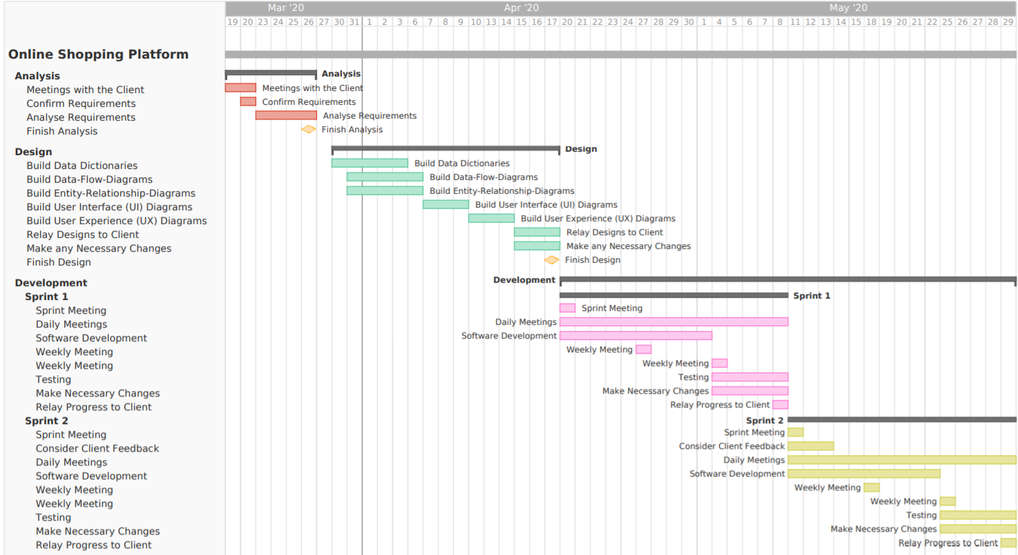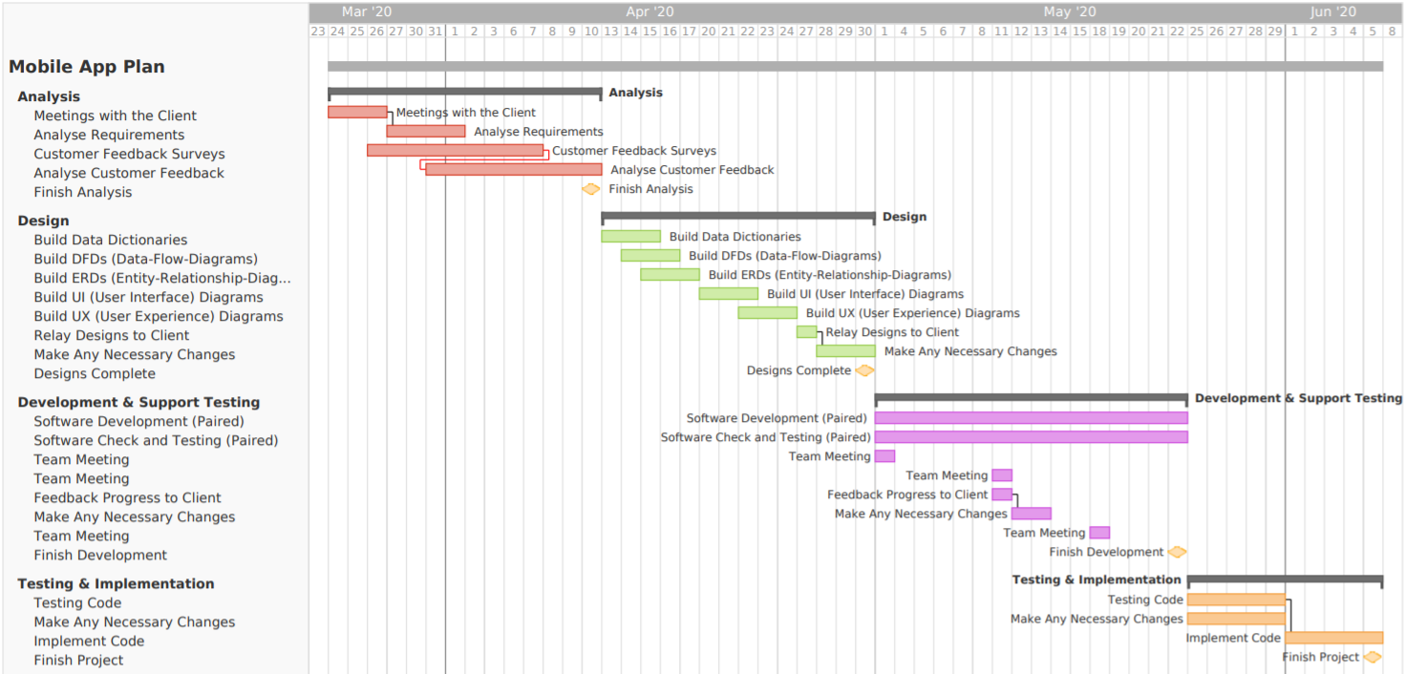

Figure 1 : Hairdresser App Gantt Chart

Figure 2 : Online Shopping Gantt Chart pt.1

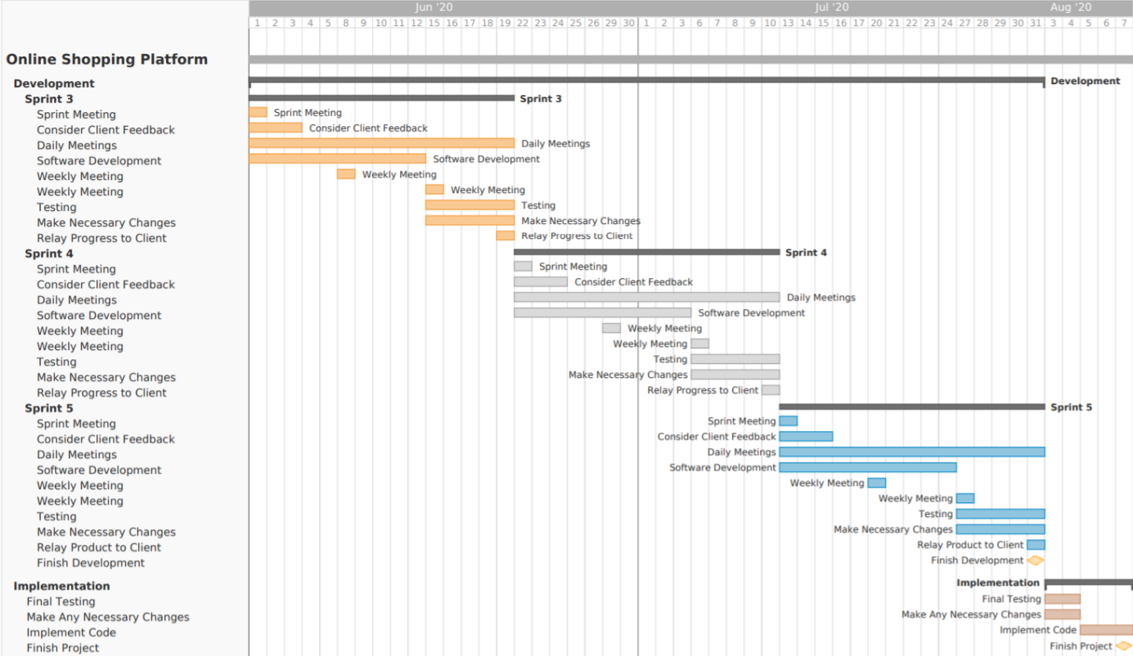

Figure 3 : Online Shopping Gantt Chart pt.2

# Bibliography

Arisholm, E., Gallis, H., Dyba, T. and Sjoberg, D., 2007. Evaluating Pair Programming with Respect to System Complexity and Programmer Expertise. IEEE Transactions on Software Engineering, 33(2), pp.65-86.

Azure.microsoft.com. n.d. What Is Devops? Devops Explained | Microsoft Azure. [online] Available at: <https://azure.microsoft.com/en-gb/overview/what-is-devops/#overview> [Accessed 13 March 2020].

Ball T, Kim JM, Porter AA, Siy HP. If your version control system could talk. InICSE Workshop on Process Modelling and Empirical Studies of Software Engineering 1997 (Vol. 11).

Barlow, J. and Møller, C., n.d. A Complaint Is A Gift. San Francisco: Berrett-Koehler, pp.210-213.

Barsky, J.D. and Huxley, S.J., 1992. A customer-survey tool: using the" quality sample". Cornell Hotel and Restaurant Administration Quarterly, 33(6), pp.18-25.

De O. Melo, C., S. Cruzes, D., Kon, F. and Conradi, R., 2013. Interpretative case studies on agile team productivity and management. Information and Software Technology, 55(2), pp.412-427.

Dittmer, M 2019, GitLab Project management, Metropolia University of Applied Sciences, Helsinki, Finland.

Extremeprogramming.org. n.d. Extreme Programming: A Gentle Introduction.. [online] Available at: <http://www.extremeprogramming.org/> [Accessed 14 March 2020].

Gianpeiro, C. and Khatereh, Y., 2019, ‘Moving from local server to cloud service using Microsoft Azure’, Master of Science Thesis, Politecnico di Torino, Torino.

GitLab. Documentation. [online] Available at: <https://about.gitlab.com/handbook/documentation/> [Accessed 16 March 2020].

GitLab. n.d. The First Single Application For The Entire Devops Lifecycle - Gitlab. [online] Available at: <https://about.gitlab.com/> [Accessed 9 March 2020].

Gitlab.com. n.d. Wiki | Gitlab. [online] Available at: <https://docs.gitlab.com/ee/user/project/wiki/> [Accessed 10 March 2020].

Hethey, J., 2013. Gitlab Repository Management. Birmingham: Packt Publishing.

Hunt, J., 2006. Agile Software Construction. London: Springer, pp.161-182.

Johnson, D. and Caristi, J., 2002. Using Extreme Programming in the Software Design Course. Computer Science Education, 12(3), pp.223-234.

Keil, M., Rai, A., Cheney Mann, J. and Zhang, G., 2003. Why software projects escalate: The importance of project management constructs. IEEE Transactions on Engineering Management, 50(3), pp.251-261.

Li, Q. and Chen, Y.L., 2009. Data flow diagram. In Modelling and Analysis of Enterprise and Information Systems (pp. 85-97). Springer, Berlin, Heidelberg.

Mcdowell, C., Werner, L., Bullock, H. and Fernald, F., 2003. "The impact of pair programming on student performance, perception and persistence," 25th International Conference on Software Engineering, 2003. Proceedings., pp. 602-607.

Moe, N., Dingsøyr, T. and Dybå, T. (2010). A teamwork model for understanding an agile team: A case study of a Scrum project. Information and Software Technology, 52(5), pp.480-491.

Mullen, B., Johnson, C. and Salas, E., 1991. Productivity Loss in Brainstorming Groups: A Meta-Analytic Integration. Basic and Applied Social Psychology, 12(1), pp.3-13.

Năftănăilă, I., 2008. Critical Analysis Of The Scrum Project Management Methodology. Bucharest: The Academy of Economic Studies Bucharest, pp. 437-438.

Nagappan, N., Williams, L., Ferzli, M., Wiebe, E., Yang, K., Miller, C. and Balik, S., 2003. Improving the CS1 experience with pair programming. ACM SIGCSE Bulletin, 35(1), pp.359-362.

Rossberg, J., 2019. Agile Project Management With Azure Devops. Apress, p.53.

Rust, R. and Zahorik, A., 1993. Customer satisfaction, customer retention, and market share. Journal of Retailing, 69(2), pp.200-215.

Sandler, C., Badgett, T. and Myers, G., 2013. The Art Of Software Testing. Hoboken, N.J.: Wiley, pp.11-12.

Schwalbe, K., 2008. Information Technology Project Management. Centage Learning, pp.12-13.

Scrum (2018). A Brief Overview of the Scrum Framework. [video] Available at: https://www.youtube.com/watch?time_continue=75&v=gy1c4_YixCo&feature=emb_logo [Accessed 8 Mar. 2020].

Scrum.org. (n.d.). What is Scrum?. [online] Available at: https://www.scrum.org/resources/what-is-scrum [Accessed 8 Mar. 2020].

Simon, B. and Hanks, B., 2008. First-year students' impressions of pair programming in CS1. Journal on Educational Resources in Computing (JERIC), 7(4), pp.1-28.

Spinellis, D., 2005. Version control systems. IEEE Software, 22(5), pp.108-109.

Tan, C. and Zhou, J., 2002. "An electronic payment scheme allowing special rates for anonymous regular customers," Proceedings. 13th International Workshop on Database and Expert Systems Applications. pp. 428-432.

Tasker, S.C., 1998. Bridging the information gap: Quarterly conference calls as a medium for voluntary disclosure. Review of Accounting Studies, 3(1-2), pp.137-167.

Uhrowczik, P., 1973. Data Dictionary/Directories. IBM Systems Journal, 12(4), pp.332-350.

Zhu, L., Bass, L. and Champlin-Scharff, G., 2016. DevOps and Its Practices. IEEE Software, 33(3), pp.32-34.